Interfacing Push buttons to 8051 Development kit using Interrupts


LAB # 04

Spring 2024
CSE-307L Microprocessor Based System Design Lab

Submitted by: Ali Asghar
Registration No.: 21PWCSE2059
Class Section: C

“On my honor, as student of University of Engineering and Technology, I have neither given nor received unauthorized assistance on this academic work.”

Submitted to:
Dr. Asif Ali Khan

Date:
22nd March 2024

Department of Computer Systems Engineering
University of Engineering and Technology, Peshawar

Task 1:
Run the program given in the slides and attach both code and proteus Screen shot.

Code:
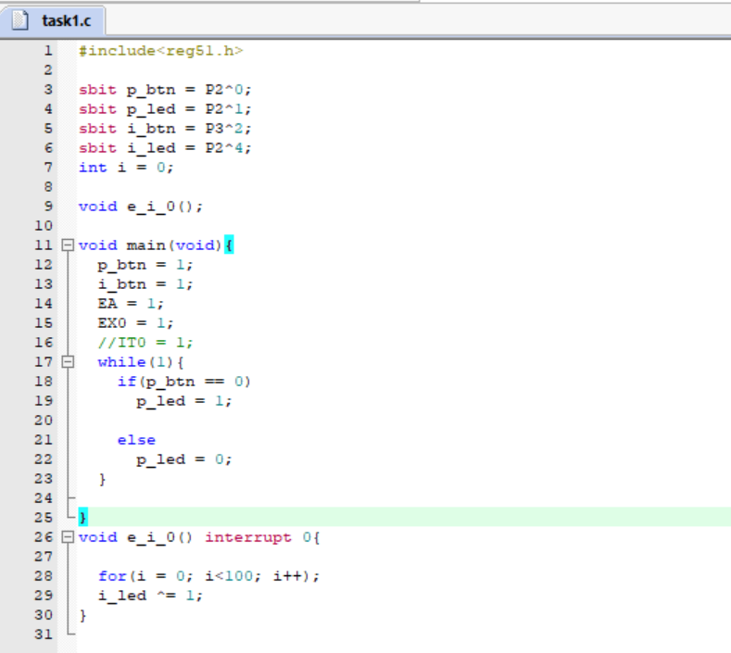

Output:
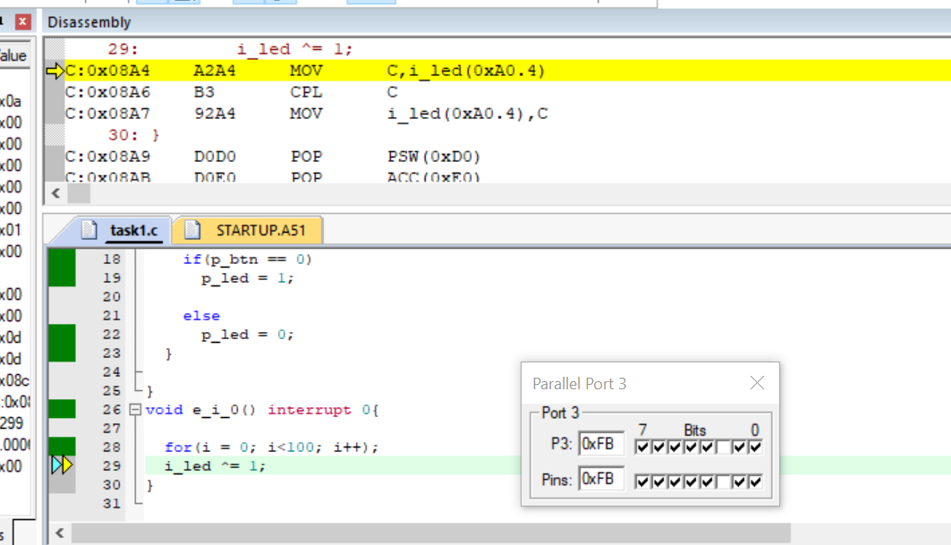

Proteus Simulation:
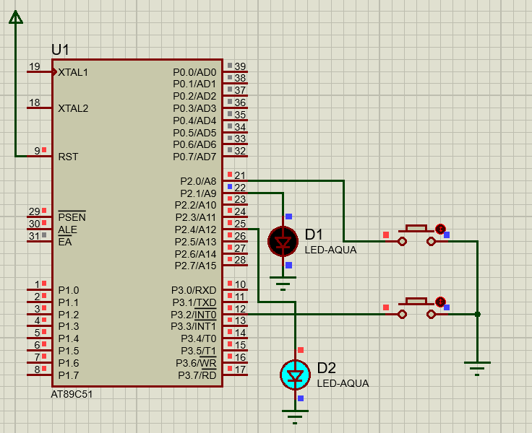
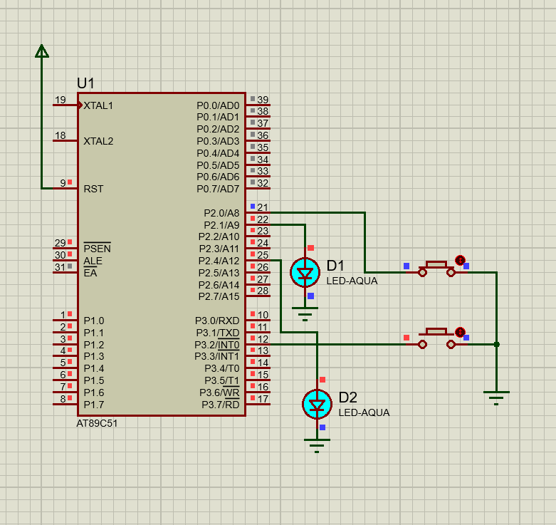

Task 2:
Attach 7seg-BCD with PORT1 and whenever interrupt occur at PORT3 (P3^2) display in the seven segment. On pressing the button it display 1 again pressing the button it should display 2.
Hint: Increment PORT1 when an interrupt occur

Code:
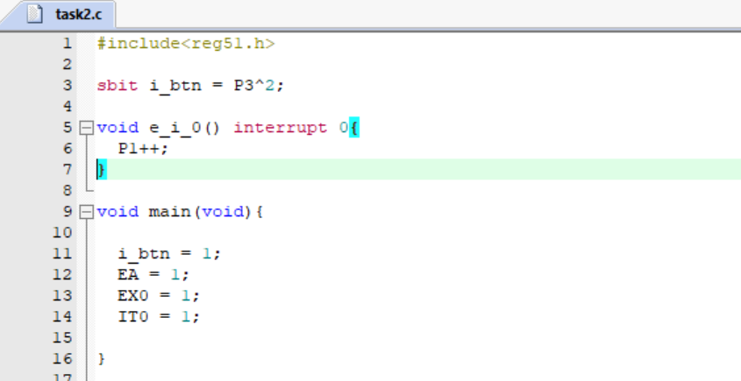

Output:
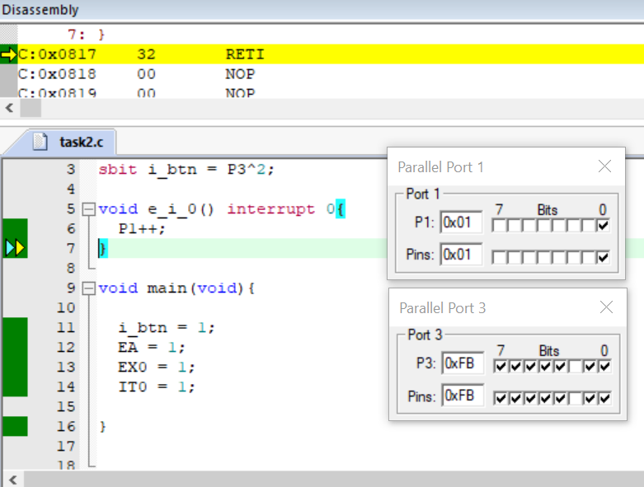
Proteus Simulation:
